COP Spraint collection protocol
Objectives:
Collection of otter spraint (droppings) in order to determine prey species. Extending records of otters around the Cornish coast.
Identification of otter spraint.
Otters use their spraint in order to mark ranges/territories and boundaries. The spraints are generally left on prominent features along the banks or within water courses or bodies. Spraint sites are often large rocks, tree stumps or fallen branches. On gravel or sand banks the otter may scrape up a small heap of sand and spraint on top of this. Regular sites may be used by multiple individuals and there may be small heaps of old dried spraints together with staining of the substrate.
Freshly deposited spraints are tarry black with visible small bones and scales. They are about 10 mm across and may be up to 100 mm long. The spraint has a distinctive and not unpleasant smell usually described as similar to jasmine tea.
Spraints are fairly distinctive although other mustelid droppings, especially mink, may be found in similar locations. Mink scat has an unpleasant musty smell and usually contains a lot of hair.
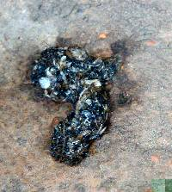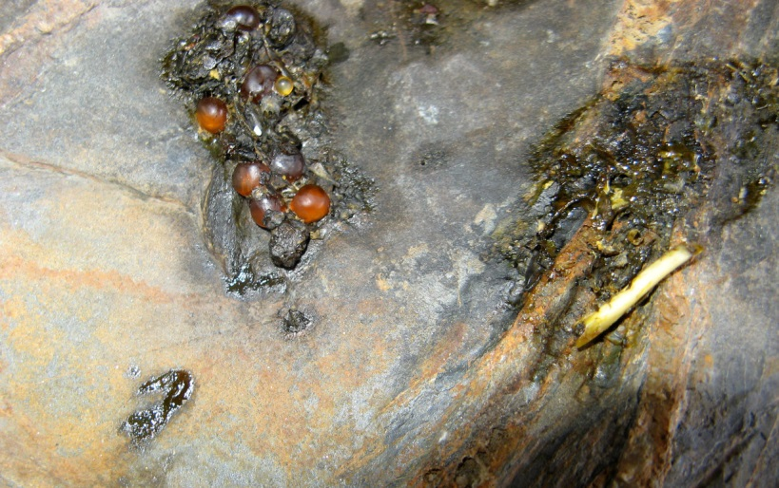
Typical spraint with bones and scales
Spraint with Salmonid eggs
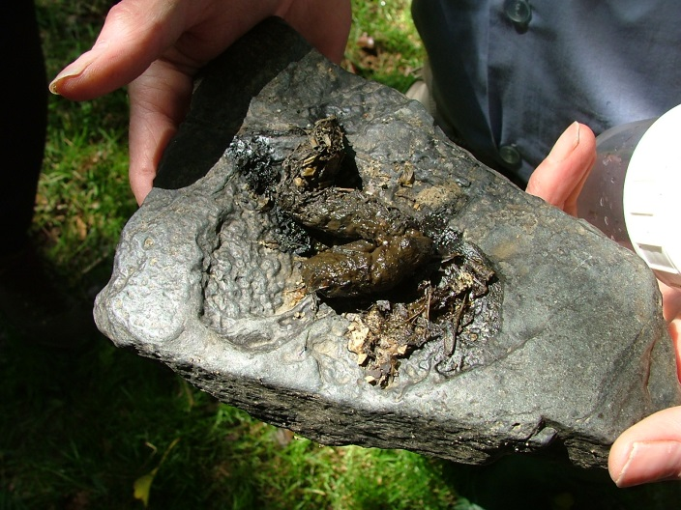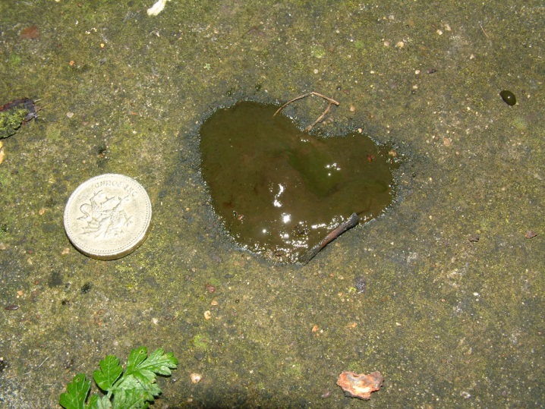
Spraints are typically the size of a cigarette – some samples are a lot larger!
On occasion the spraint may contain no obvious prey remains but still smells strongly of otter – this is ‘anal jelly’ and may be purely concedrned with scent marking. This is of little use for the CCOP but is still a useful record and may be on a site worth revisiting.
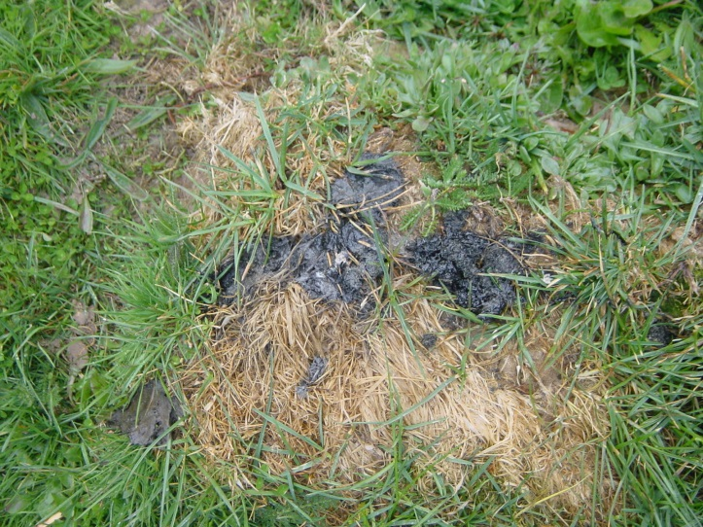
Otters will often use tussocks or ant hills where other features are not available. The frequent use can kill the grass but the surrounding grass may be very green from nutrient enrichment.
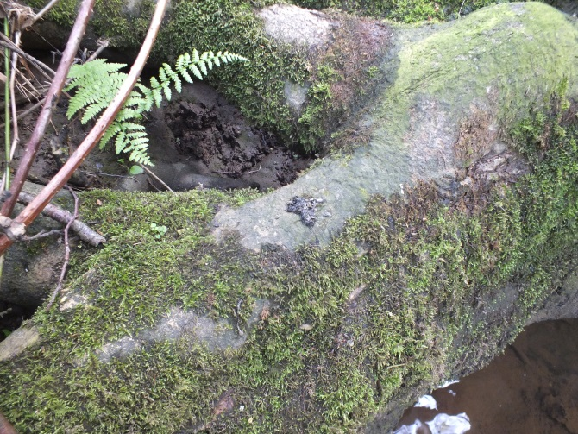
Sprainting site by river on tree roots. Typically sites are about 100m apart and are usually on prominent features along the river. Sites are often where feeder streams join or where the river narrows such as at a bridge or weir.
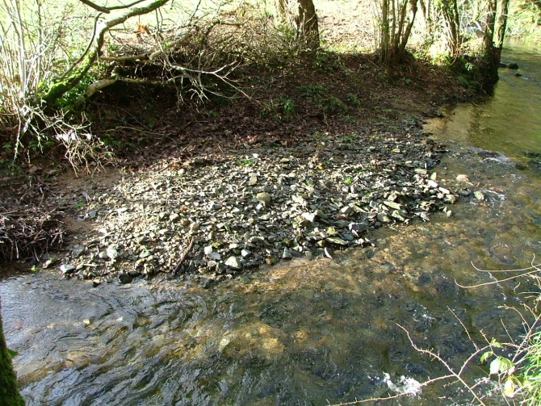
Otters often spraint on sand or gravel banks. They may use a larger stone or they may scrape the ground into a small heap and deposit spraint on or near this.
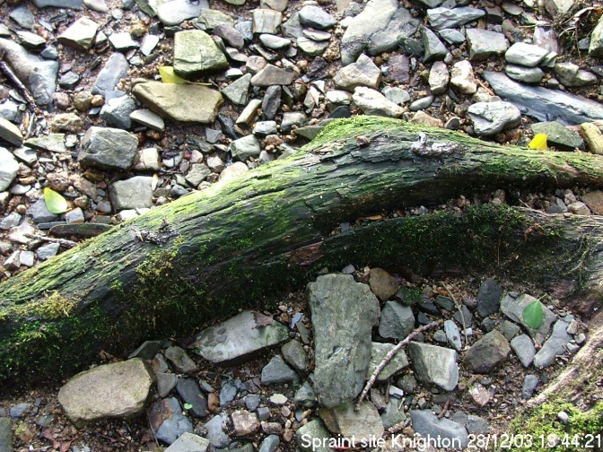
Here an old piece of timber in the gravel has been used.
Collection protocol.
We hope to be able to carry out DNA analysis on some of the spraint samples in the future so we have provided collection bags and scoops. Once a spraint has been identified use the wooden spatula to lift as much of the sample as possible into a zip-loc bag. If more than one spraint is present use a separate spatula and bag to collect into. Label each bag clearly with the date, site location, and your name.
All samples should be returned to the collection point either in the return envelope or via one of the listed contacts.
Spraint is used by otters to communicate and mark ranges. Please do not remove spraint from any one site more often than once in a month.
Health and Safety
Spraint collection usually involves rocks and water – please be aware of your surroundings at all time, do not take any risks in accessing spraint sites. On coastal sites please take note of the tides and always take a phone with you. Estuary sites may include deep mud, do not get stuck! If you are heading out on your own please make sure someone knows where are you are going and when to expect you back.
Always wear gloves if handling spraint and wash your hands thoroughly afterwards. Weils disease (leptospirosis) is always a risk to those working in and around water bodies. If you develop flu-like symptoms make sure to let your doctor know. Ticks may also be present – please take precautions to avoid bites and watch out for signs of Lyme disease.
Do not enter any water unless you are sure you can get out again. Avoid any deep water and always carry a stick with you to test depth.
Be aware of any domestic stock or dogs in the area.

Dave Groves
Cornwall Mammal Group 2018

